**Second Grade News**

**From the classes of Mrs. Bautch and Mrs. Slade**

**1-7-16**

Math

This week, we have begun our work in chapter 6 of *My Math*. The lessons in this chapter connect with the theme of “This is My Town,” which centers on maps and travel. The second graders are continuing to learn strategies to add 3-digit numbers. They are practicing making one number one hundred to make mental addition easier. They are also noting that recalling basic facts can help them solve 3-digit addition problems. Finally, the children are mentally adding 10 and 100 to multiple digit numbers.

# Language Arts

Our reading this week has focused on how the Earth’s forces affect us. We have been talking about forces that we can observe. In word work, the children are reading and writing words with various spelling combinations that make the long *a* sound. These include *ai, ay, ea, eigh,*and *ey.* They are also learning about similes. (the comparison of one thing with another thing of a different kind such as *brave as a lion*.) Finally, we are spending time considering and discussing the author’s purpose for his/her writing.

# Writing Workshop

During our writing lessons, the second graders have been finishing their demonstration books. Thank you for taking time at home to help your child with the beginning of this project. The children have focused on creating a sequence of steps and using time-order words such as first, next, and last. The student instructions will be shared in both written and oral formats. You should have received a slip with your child’s oral presentation date. **He/she will need his/her supplies at that time.**

Literature

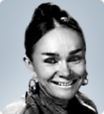

Our January author is Patricia Polacco. Ms. Polacco teaches us how life happenings and the richness of family and traditions help her in developing her heartwarming stories. Her books are wonderful models for inspiring our students to write about their own life experiences during Writing Workshop.

Social Studies

Learning about Social Studies can be fun and exciting. An area of Social Studies popular with children is geography. Our second graders are learning about the various types of landforms. They are also learning about tools which help us to understand maps and globes.

# Book-It!

Your child’s January Book-It! form was sent home this week. Please encourage your child to read daily. This Book-It! form is due by the end of January. Please try to finish up and return November and December Book-It! forms if you haven’t already done so. You can include extra books read in January to finish up these forms. Your child should know if he/she is missing a month.

Happy New Year!

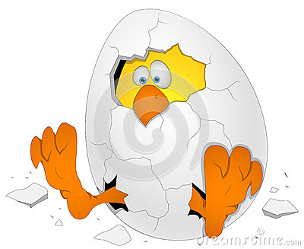We’ve “cracked open” a new year of learning!