**Second Grade News**

**From the classes of Mrs. Bautch and Mrs. Slade**

**10-22-15**

Math

This week the second graders completed chapter 2 in which we focused on skip counting, repeated addition with arrays, odd and even numbers, and missing addends. The children showed what they learned through the chapter 2 assessment.

We have now begun to learn about taking apart tens to add. For example:

37+24=

37+20+4

57+4=61

# Language Arts

This week our class has been reading about and discussing the topic of pets. We are learning about pets and how they can be important friends. The second graders are identifying the character, setting, and events of stories. They are also learning how sentence clues can help to explain the meaning of a word in text. The children are learning about two-letter blends at the beginning and end of words. These include the *r*- blends (*crack*), *s*-blends (*slide*), and *t*-blends (*past)*.

In writing, the children are focused on editing skills. They are correcting the mechanical mistakes of capitalization and end punctuation. They are also working to develop strong story beginnings.

Science

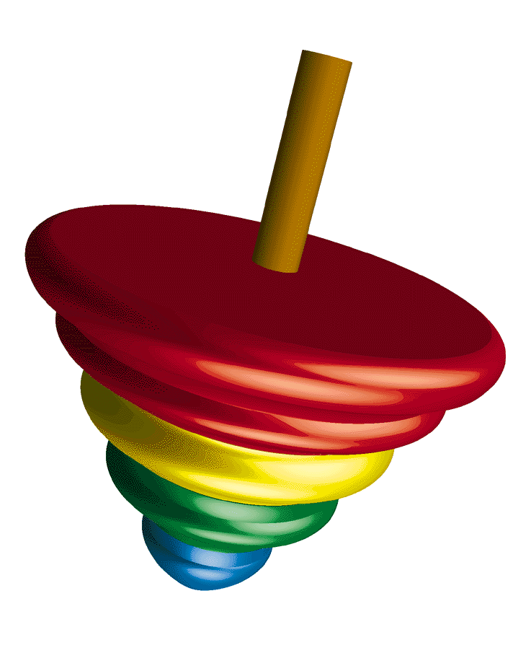

The children have begun exploring and observing the scientific concept of balance and motion through numerous experiments. We have discussed the terms balance point, stable positions, and counterweights.

# Literature

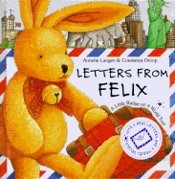

Our literature book this week is titled *Letters From Felix*. Felix is a cuddly rabbit who belongs to a little girl named Sophie. At the end of Sophie’s family vacation, Felix gets lost at the airport. Soon after, Sophie begins to receive letters from Felix. Letters arrive from London, Paris, Rome, Cairo, Kenya, and New York. Felix’s letters describe the lands and people he visits.

# Social Studies

We are mapping the travels of our literary character, Felix.

Unity Parade

Second grade held its second annual Unity Day Parade on Wednesday. We paraded around the main hallways and were supported by our friends from other grades and the entire Oak Hill staff as we displayed our anti-bullying messages on our painted T-shirts.

Beads on One String

Today we were treated to a presentation by Dennis Warner, the creator of the song “Beads on One String.” We also are able to enjoy the very large “Beads on One String” project created by all of us at Oak Hill. Each of our beads is unique, yet all are held together by one string. This represents our connectedness in the world.

Fall Festival

Enjoy Oak Hill’s Fall Festival this evening from 5:00-8:00.